Note: For Bonus task I have already installed the VirtualBox in my machine and downloaded the fresh ubuntu 22.04 LTS iso image from the official website of ubuntu and installed it on VirtualBox.

Further, I have done below mentioned tasks for performing the bonus task.

Q1. Install Nginx inside the Ubuntu machine and host a website.

1. After starting the Ubuntu, I installed the nginx sever in that VM.
2. Command used for nginx installation is sudo apt-get install nginx.
3. Checked the installation is successful or not by below command.
4. Systemctl status nginx.

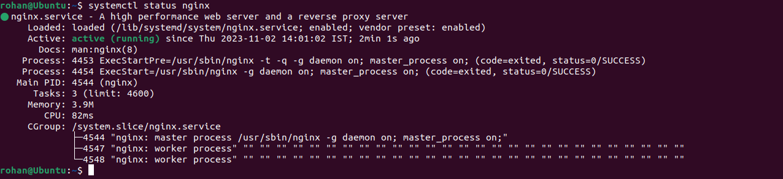

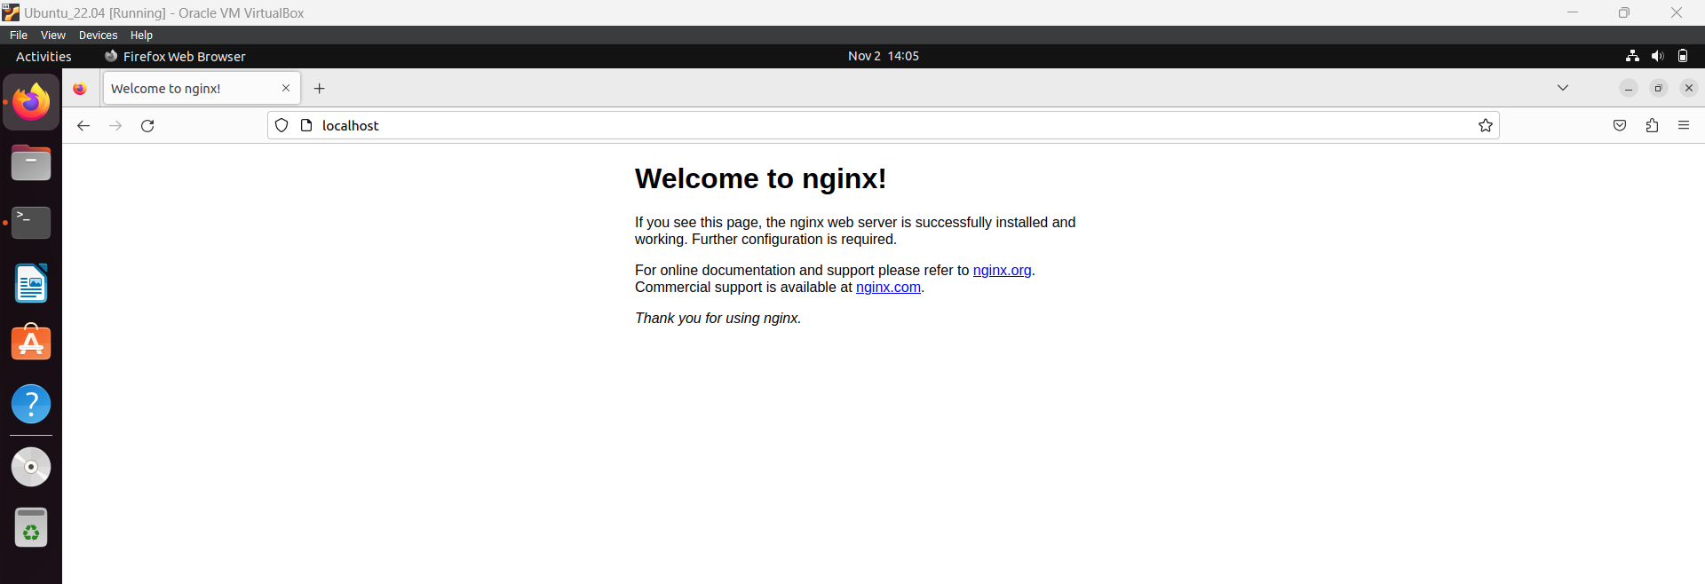

1. After that I changed the html code for nginx just as I did in Windows and added one hyperlink to download Devil May Cry 5 Game.
2. Also added one hosts entry for downloaddmc5.com so that we can access that website from that domain as well.

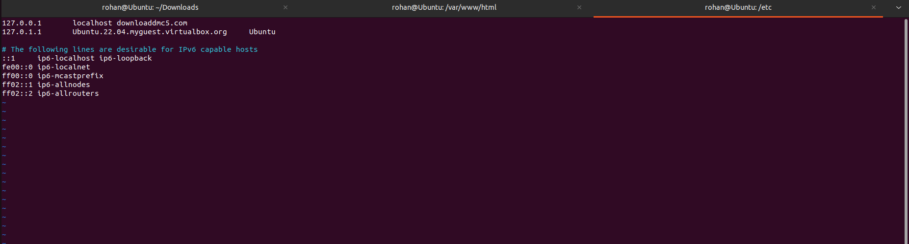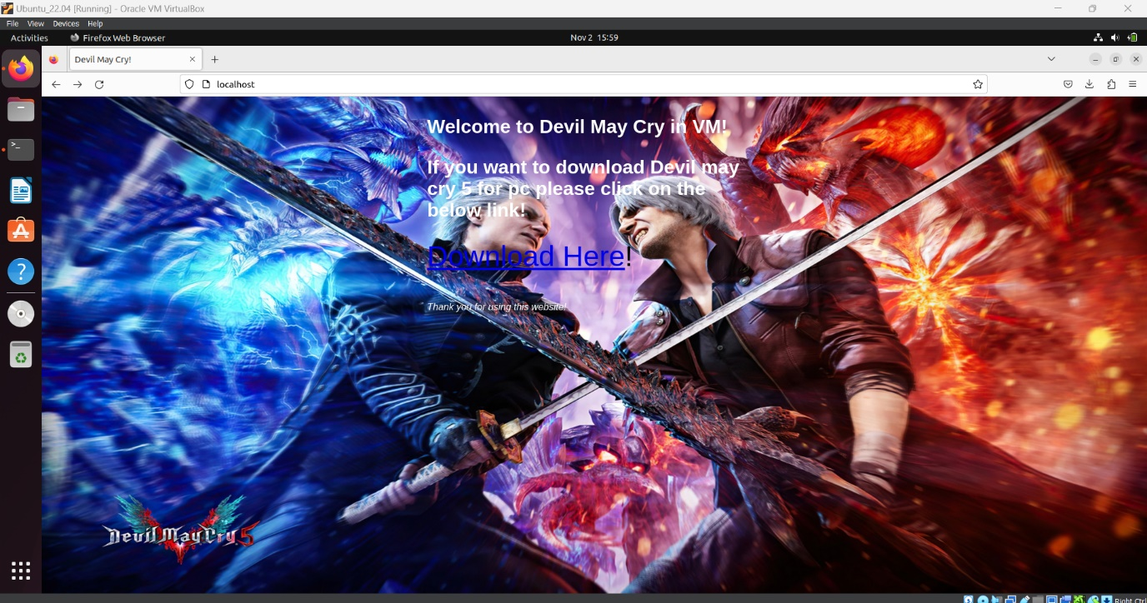

1. Hyperlink works fine if we click on the link then it will show the download page.
2. Also, I tried the nmap from my host machine i.e. Windows 11 to my VM Ubuntu 22.04 and below is the result I got.

**C:\Users\rohan>nmap -T4 -A -v 192.168.56.101**

Starting Nmap 7.94 ( https://nmap.org ) at 2023-11-03 10:42 India Standard Time

NSE: Loaded 156 scripts for scanning.

NSE: Script Pre-scanning.

Initiating NSE at 10:42

Completed NSE at 10:42, 0.00s elapsed

Initiating NSE at 10:42

Completed NSE at 10:42, 0.00s elapsed

Initiating NSE at 10:42

Completed NSE at 10:42, 0.00s elapsed

Initiating ARP Ping Scan at 10:42

Scanning 192.168.56.101 [1 port]

Completed ARP Ping Scan at 10:42, 0.08s elapsed (1 total hosts)

Initiating Parallel DNS resolution of 1 host. at 10:42

Completed Parallel DNS resolution of 1 host. at 10:42, 0.00s elapsed

Initiating SYN Stealth Scan at 10:42

Scanning 192.168.56.101 [1000 ports]

Discovered open port 22/tcp on 192.168.56.101

Discovered open port 80/tcp on 192.168.56.101

Completed SYN Stealth Scan at 10:42, 0.18s elapsed (1000 total ports)

Initiating Service scan at 10:42

Scanning 2 services on 192.168.56.101

Completed Service scan at 10:42, 6.01s elapsed (2 services on 1 host)

Initiating OS detection (try #1) against 192.168.56.101

NSE: Script scanning 192.168.56.101.

Initiating NSE at 10:42

Completed NSE at 10:42, 5.14s elapsed

Initiating NSE at 10:42

Completed NSE at 10:42, 0.05s elapsed

Initiating NSE at 10:42

Completed NSE at 10:42, 0.01s elapsed

Nmap scan report for 192.168.56.101

Host is up (0.0014s latency).

Not shown: 998 closed tcp ports (reset)

**PORT STATE SERVICE VERSION**

**22/tcp open ssh OpenSSH 8.9p1 Ubuntu 3ubuntu0.4 (Ubuntu Linux; protocol 2.0)**

**| ssh-hostkey:**

**| 256 e4:16:ca:d2:4e:e1:74:be:a8:51:b8:07:7f:dd:84:c4 (ECDSA)**

**|_ 256 ac:c6:ff:dd:be:8d:2c:71:a2:ff:d0:71:ea:56:58:d0 (ED25519)**

**80/tcp open http nginx 1.18.0 (Ubuntu)**

| http-methods:

|_ Supported Methods: GET HEAD

|_http-title: Devil May Cry!

|_http-server-header: nginx/1.18.0 (Ubuntu)

MAC Address: 08:00:27:25:02:6D (Oracle VirtualBox virtual NIC)

Device type: general purpose

Running: Linux 4.X|5.X

OS CPE: cpe:/o:linux:linux_kernel:4 cpe:/o:linux:linux_kernel:5

OS details: Linux 4.15 - 5.8

Uptime guess: 42.103 days (since Fri Sep 22 08:14:10 2023)

Network Distance: 1 hop

TCP Sequence Prediction: Difficulty=261 (Good luck!)

IP ID Sequence Generation: All zeros

Service Info: OS: Linux; CPE: cpe:/o:linux:linux_kernel

TRACEROUTE

HOP RTT ADDRESS

1 1.44 ms 192.168.56.101

NSE: Script Post-scanning.

Initiating NSE at 10:42

Completed NSE at 10:42, 0.02s elapsed

Initiating NSE at 10:42

Completed NSE at 10:42, 0.01s elapsed

Initiating NSE at 10:42

Completed NSE at 10:42, 0.00s elapsed

Read data files from: C:\Program Files (x86)\Nmap

OS and Service detection performed. Please report any incorrect results at https://nmap.org/submit/ .

Nmap done: 1 IP address (1 host up) scanned in 13.72 seconds

Raw packets sent: 1023 (45.806KB) | Rcvd: 1019 (41.494KB)

C:\Users\rohan>

1. The ports which are showing open is 80 and 22. I have installed the openssh server for accessing the VM through my host machine via SSH. So that is showing correct.